

PRESIDENT’S OFFICE
REGIONAL ADMINISTRATION AND LOCAL GOVERNMENT MVOMERO DISTRICT COUNCIL

FORM TWO MOCK EXAMINATION

012 HISTORY

Time: 3 Hours MAY 2023

Instructions
- This paper consists of sections A,B and C with a total of ten (10) questions
- Answer all questions
- Section A and C carry fifteen (15) marks each and Section B carries seventy (70) marks

- For each of the items (i) – (x) choose the correct answer from among the given alternative and write its letter in the box provided.
  - What were the important salt making centres in pre-colonial Africa?
    - Taghaza and Uvinza B. Auxum and Meroe
C. Engaruka and Uvinza D. Nok and Taghaza
E. Ugweno and Bilma
  - Who were the earliest inhabitants in South Africa?
    - Ndebele and Zulu B. Ngoni and Bantu
C. San and Khoikhoi D. Cushites and San
E. Boers and Dutch
  - Which set consist of components of economic interaction
    - Marriage, religion, medicine and migration.
    - Music, migration, trade and metal working
    - Agriculture, Fishing, trade and metal working.
    - Fishing, marriage, medicine and migration.
    - Trade, medicine, wars and agriculture
  - Who was a systematic tool maker during the evolution of man.
    - Homo Habilis B. Zinjanthropus
C. Homo Sapiens D. Homo Erectus
E. Zinjanthropus
  - Two students from Morogoro region organized a study tour to Kilimanjaro region where they saw beans, maize and few trees planted in the same farm. Which term describe such type of agriculture
    - Crop rotation B. Agroforestry
C. Intercropping D. Mixed farming
E. Pastoralism
  - The method of obtaining historical information by studying language and their change.
A. Archaeology | B. | Linguistic
C. Historical sites | D. | Anthropology
E. Museums

  - Which of the following African societies developed Ntemiship system in East Africa by the 15th
century?
    - Nyamwezi and Chagga B. Nyamwezi and Dorobo
C. Nyamwezi and Sukuma D. Sandawe and Nyamwezi
E. Kimbu and Chagga
  - The History teacher asked John to list down five commodities which were brought by Portuguese in East Africa. Which correct list of commodities was John supposed to give:
    - Cassava, cotton, clothes, sisal and glass,
    - Gun powder, clothes, glass swords and animation
    - Slaves, beeswax, guns, animal skin, and cooper.
    - Frying pans, gun powder, wine glass and clothes.
    - Sisal, cotton, maize and clothes
  - Written records as a source of history are more preferred to oral tradition because of the following reasons.
    - Written records do not require space
    - Oral tradition can be exaggerated and it is difficult to reproduce the same contents
    - Oral tradition are expressed in centuries
    - Oral tradition are controlled by leaders of given societies.
    - Written records is used in the schools
  - The growth and expansion of Soghai Empire was a result of
    - Geographical position and Equatorial favorable climate
    - Expansion of Gao Empire through conquering neighbouring states.
    - The emergence of Mansa Musa as strong leader
    - Development of Iron technology
    - Rose of Sundiata Keita

- Match the historical description in list A with the with corresponding historical term in list B by writing the letter of the correct response below the item number in the table provided
LIST A | LIST B
- A name given to the trade that involved Africa, America and Europe before industrial revolution  - A process that involved the exchange of goods between two different geographical regions.  - A name of the trade which involved the exchange of goods between the people of western Africa and North Africa  - A name given to the process of exchanging goods for goods  - A name given to the process of exchanging goods between people of the same geographical area such as town and village | - Trans Saharan trade  - Early trade contacts  - Long distance trade  - Local trade  - Barter trade  - Trans Atlantic slave trade  - Slave trade  - Legitimate trade

SECTION B
Answer all questions in this section

- Briefly explain the following terms
- Carbon 14 dating
- Bi-pedalism
- Age-set system
- Kinship
- Archives

- Arrange the following sentences in a chronological order by writing number 1 -5 below the corresponding position in the table provided.
  - Sharpers tools were made during the middle stone age such as spear, arrows and knives.
  - The use of iron tools increased the ability of man to produce more food population increases and later on states formation during the pre-colonial
African societies
  - The period when most man’s tools were made of stone is called stone age
  - In the Early stone age, chopping and pebble tools were made and used by man
  - It is divided into early, middle and late stone age
- Briefly answer the following question
- Why did the oral tradition become important source of history?
- Why the middle stone age became very famous stage than Old and Late stone Age?
- How the development of agriculture was the one among of the factors for rise of Buganga Kingdom?
- How did Mfecane resulted to the Ngoni migration
- Why did pre colonial people of Africa tend to use power sharing in their leadership?

- Differentiate the following historical concepts
- Centralized and non-centralized state
- Acheulian stone tools and Oldowan stone tools
- Iron smelting and iron forging
- Time line and time chart
- History and historical site

- The map below locate most famous historical sites in East Africa labelled, A, B, C,D and E. Name those historical sites.

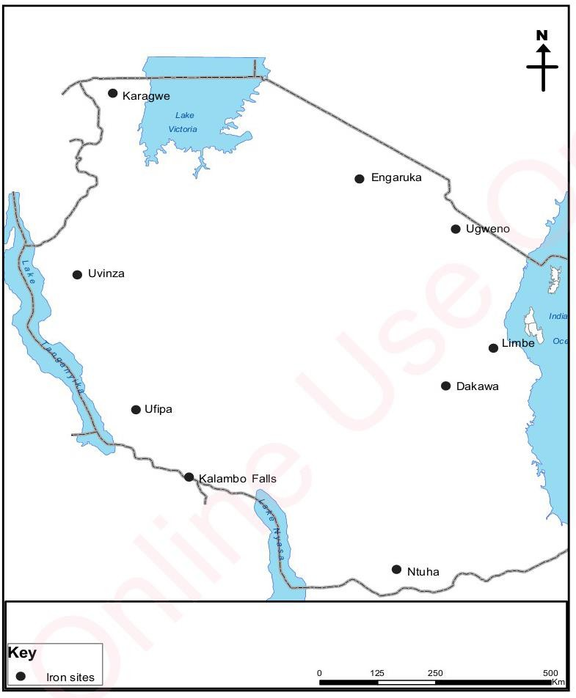
E
B
C
A
D
  - Letter A indicates
  - Letter B means _
  - Letter C indicates
  - Letter D indicates
  - Letter E means _
- Briefly describe five (05) characteristics of communalism
- Briefly explain five (05) effects of the early contact between Africa, middle east and far east

SECTION C (15 MARKS)

- Trans-sahara trade grew due to various factors. With vivid example, explain five (5) factors

_

SECTION C

Answer question 10

